Assignment 1

Step1 : Creating job in Jenkins dashboard
- Script of httpd
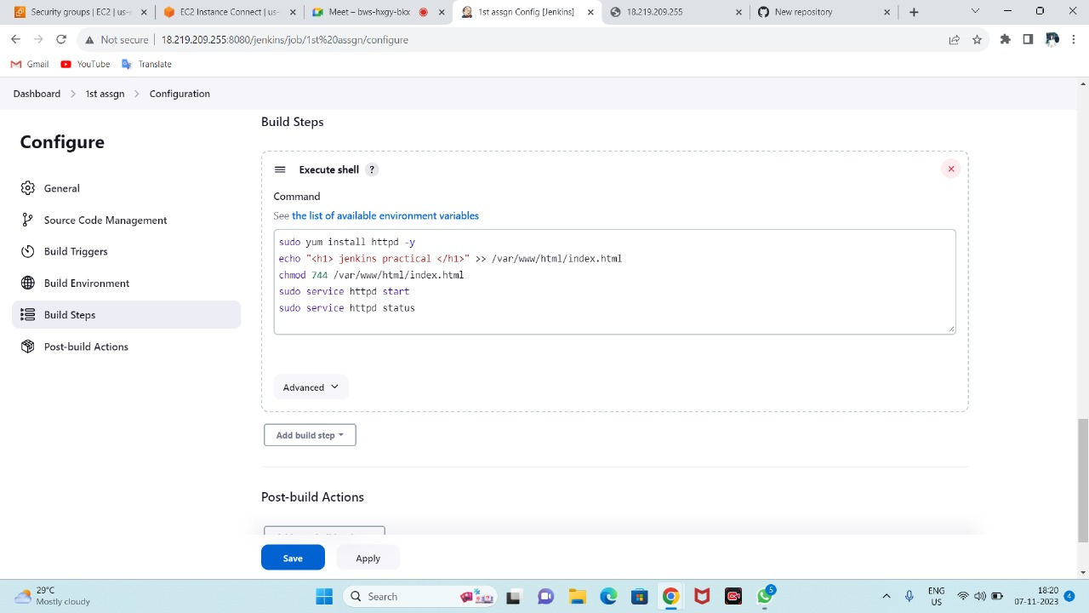

Step2: Sucessfully executed script
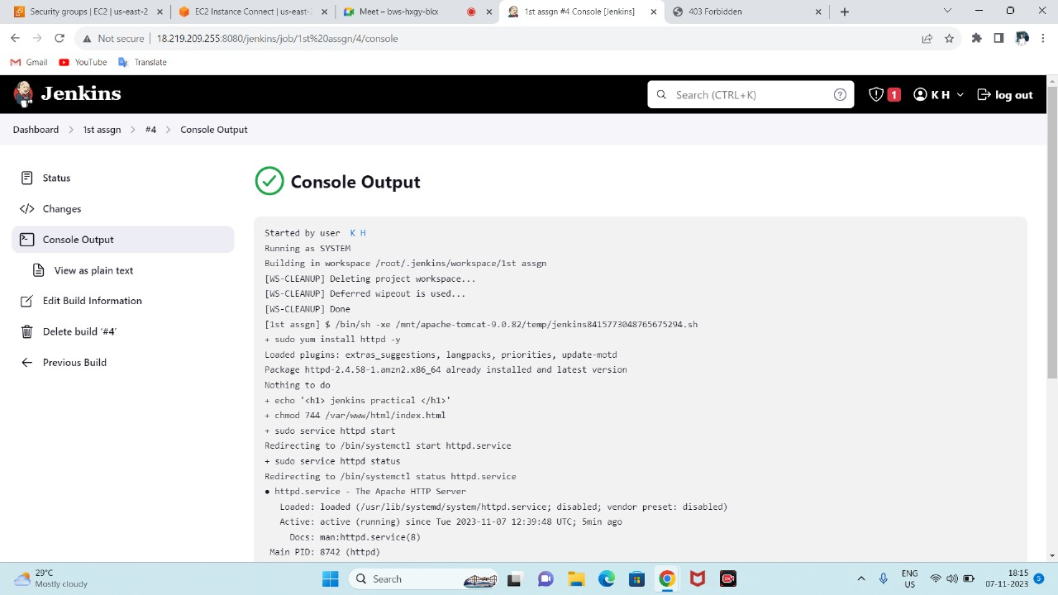

Step3: Public ip hit to browser
